**D213 Advanced Data Analytics**

**Task 1**

**Josh Rogers**

**Western Governors University**

**Contents**

**Part I: Research Question 3**

A1. Research question 3

A2. Goal 3

**Part II: Method Justification 3**

B1. Time Series Model Assumptions 3

**Part III: Data Preparation 4**

C1.  Time Series Line Graph 4

C2. Time Step Formatting 5

C3. Time Series Stationarity Evaluation 5

C4. Preparation Analysis 7

C5. Cleaned Data Set 7

**Part IV: Model Identification and Analysis 7**

D1. Annotated Findings 7

D2. ARIMA Model 8

D3. Forecast 10

D4. Output and Calculations 11

D5. Times Series Model Code 12

**Part V: Data Summary and Implications 12**

E1. Results Discussion 12

E2. Final Annotated Forecast Visualization 12

E3. Recommended Course of Action 14

**Part V: Reporting 14**

**Sources 15**

**Part I: Research Question**

**A1. Research Question**

Can a predictive time series model help the company decide whether to provide employees with a holiday bonus?

**A2.  Goal**

The goal of this analysis is to utilize the historical revenue data over the past two years to develop a time series model to predict the next 30 days of revenue. This information can then be considered for organizational budgeting purposes.

**Part II: Method Justification**

**B1. Time Series Analysis Assumptions**

To perform a Time Series Analysis (TSA) it is assumed that the dataset is stationary. This means that the mean and variance of the data should be constant throughout the analysis (Pandian, 2023). The Augmented Dickey-Fuller Test was implemented to evaluate the stationarity of the time series. The conclusion was that the series was not stationary which required the implementation of a the .diff() function in Python to help stabilize the mean of the time series. Results of the analysis will be discussed in further detail in a later section of this document.

TSA also assumes autocorrelation which is a relationship between the current value of a time series with past values (Topic 2*,* n.d.). This analysis uses both the autocorrelation function (ACF) and partial autocorrelation function (PACF) to measure the relationships of the dataset manually to consider for building the model. Additionally, AutoARIMA is utilized to evaluate the autocorrelation and provide optimal p, d, and q values.

**Part III: Data Preparation**

**C1. Time Series Line Graph**

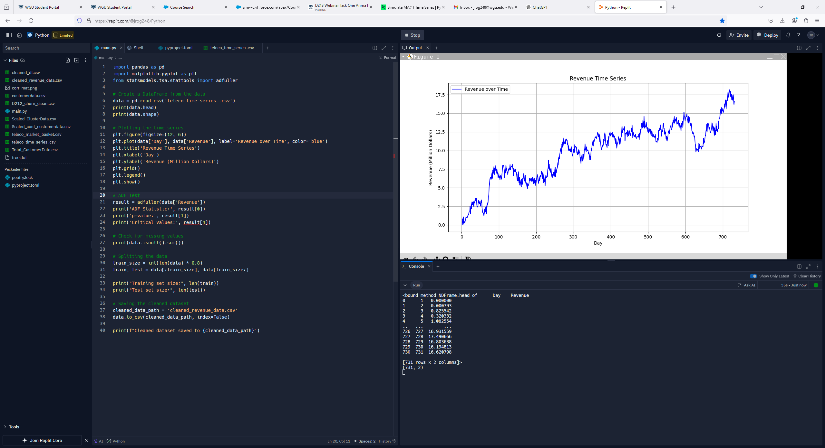

**(C1)**

**C2. Time Step Formatting**

The time steps are daily so the time series was indexed by ‘Day’. The image C1 displays the revenue data which corresponds to each day of the past two years thus demonstrating a fixed 1-day interval between instances. The dropna() method was applied to remove rows with missing or NaN values. If any days had missing revenue values in the original dataset, those rows would be dropped. The resulting length of the time series was 731. Please see code below demonstrating the above actions.

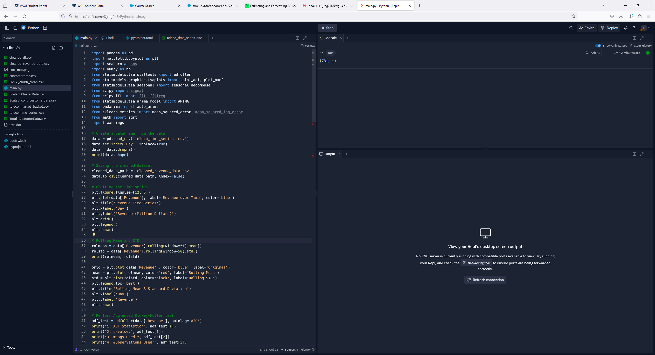



**(C2)**

**C3. Time Series Stationarity Evaluation**

A variety of methods were studied to evaluate stationarity. First, after plotting the time series data, the visualization (C1) was reviewed to determine any potential trends or seasonality. After initial review, a slight upward trend was noticed but no other discernable patterns could be found.

The next method implemented to review potential stationarity was the visualizing of the rolling mean and rolling standard deviation. Image C3 below shows a rolling mean that demonstrates the slight upward trend with no seasonality. The black line in the image represents the standard deviation and shows relatively low variance over the time series. The mean increase over time suggests non-stationarity.

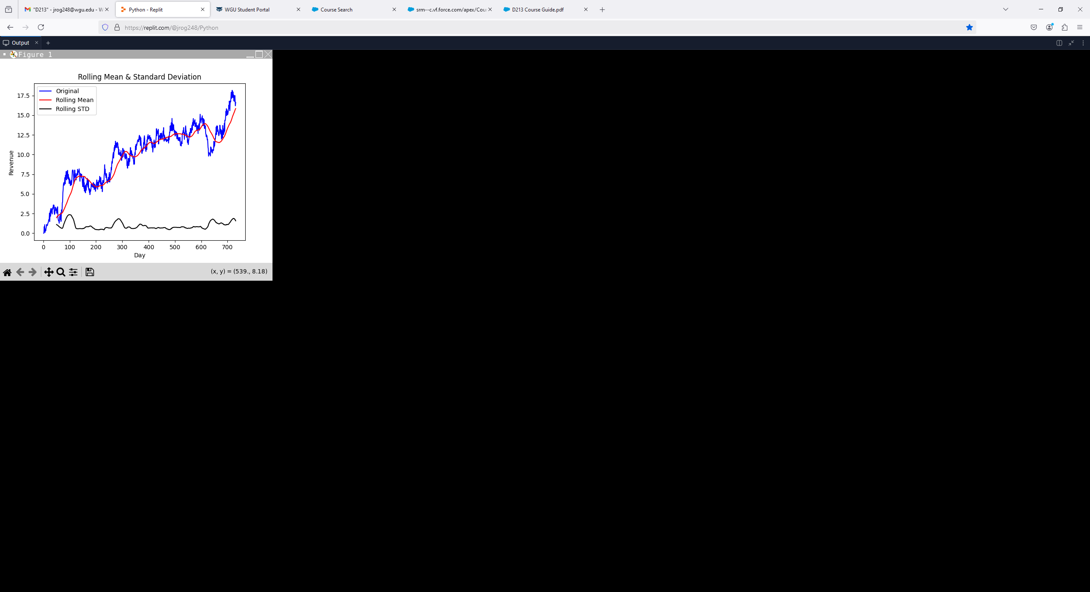

**(C3)**

A time series decomposition was then created which can be found below.

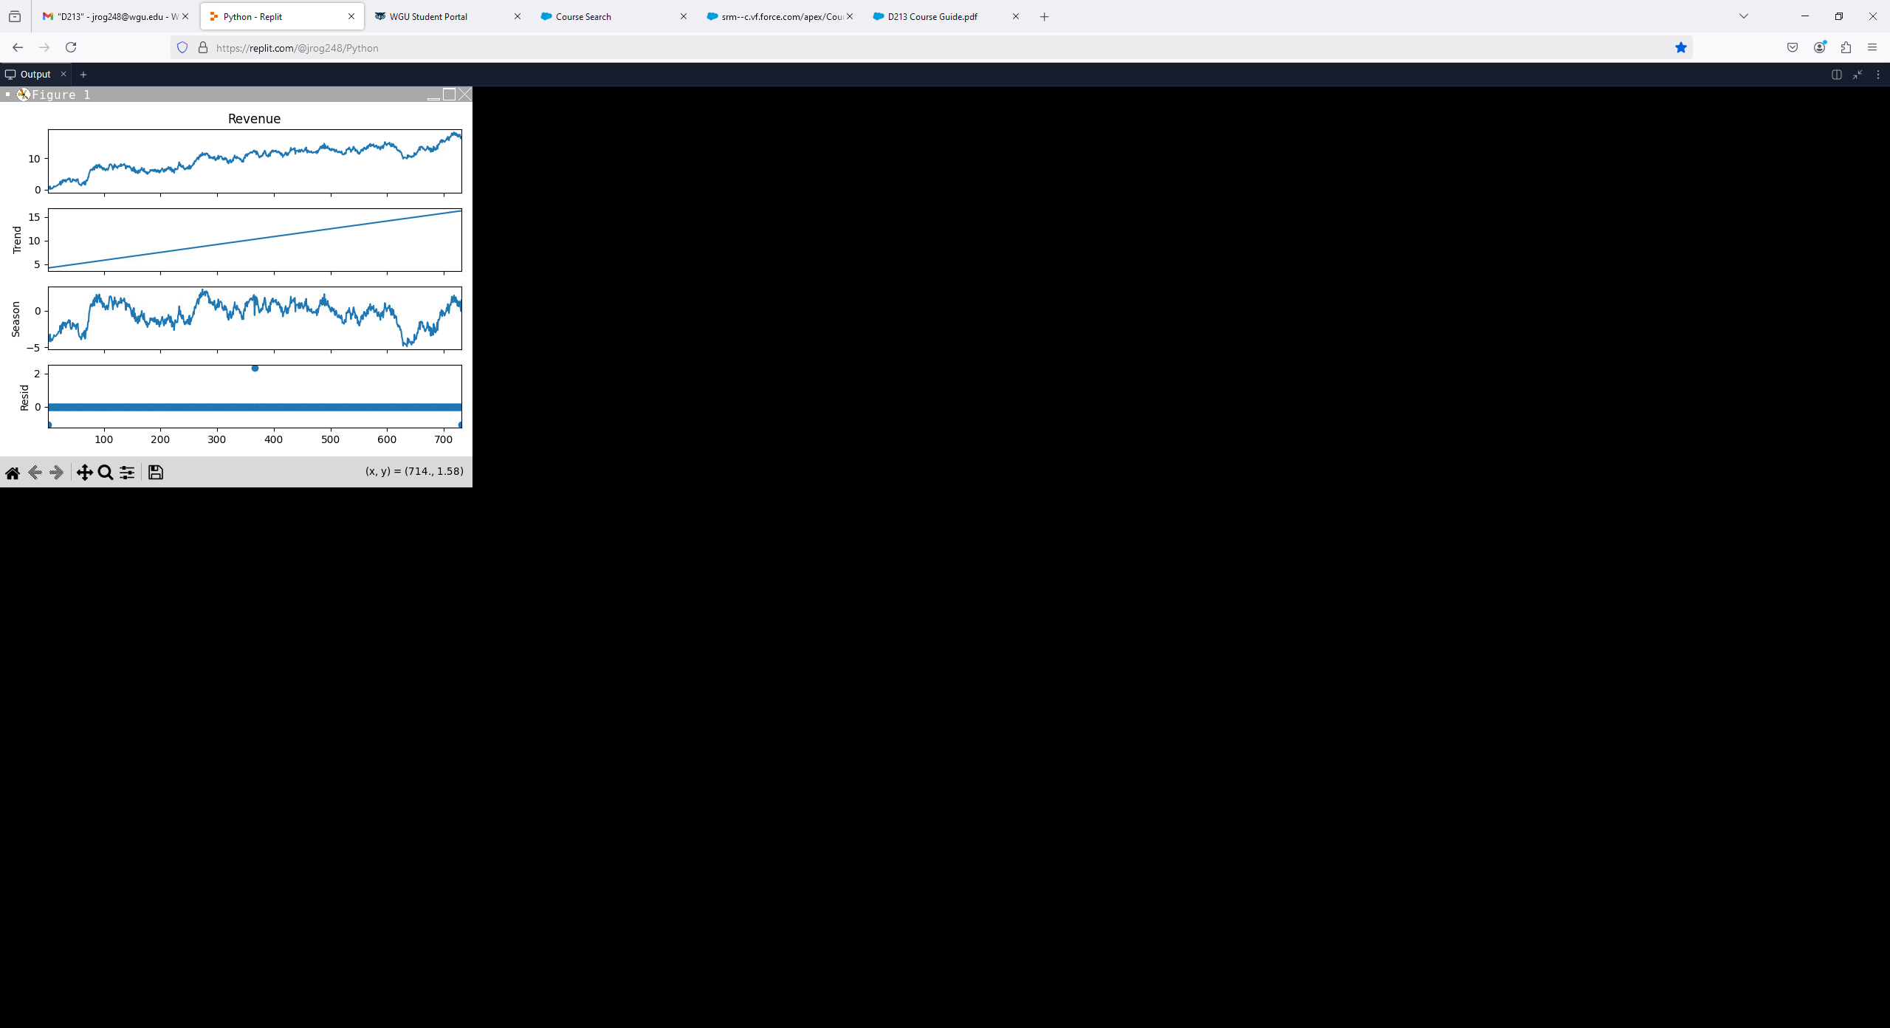

**(C4)**

The decomposition data above does not show any seasonality; however, there is an obvious upward trend in the time series further supporting the non-stationary nature of the series.

Another method utilized to evaluate stationarity was the ACF and PACF on the original revenue data. In the image C5 below, the ACF shows a slow decay which is an indicator that the time series is non-stationary. Also, the PACF shows significant variability in the first couple of lags.

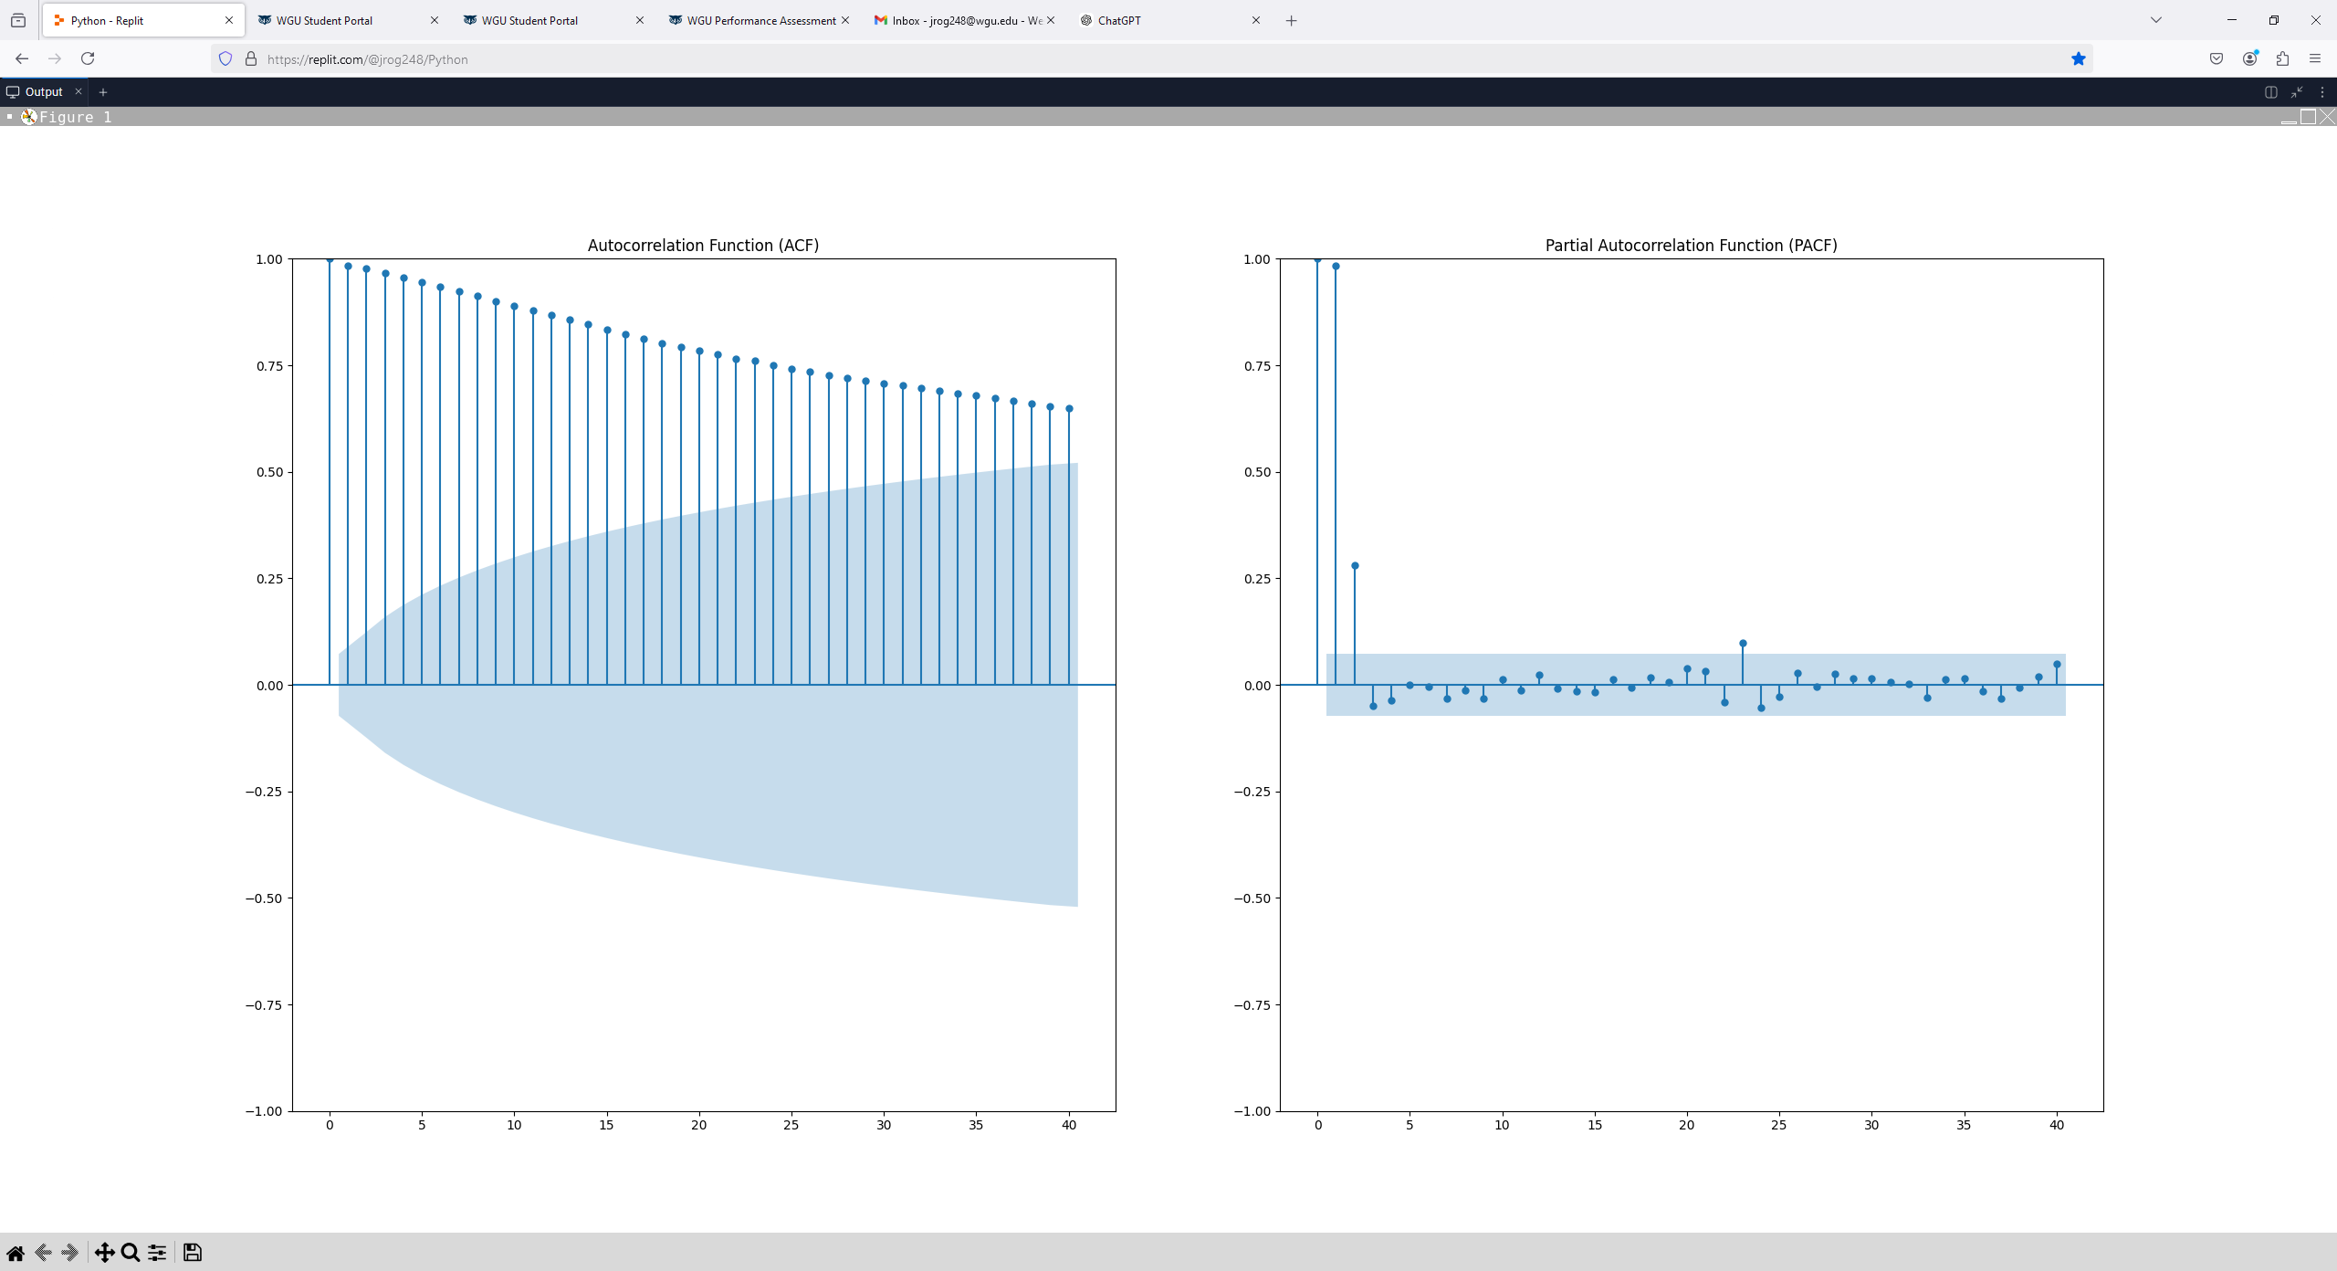

**(C5)**

The final method used to determine stationarity was the Augmented Dickey-Fuller Test. The results of this test can be found below.

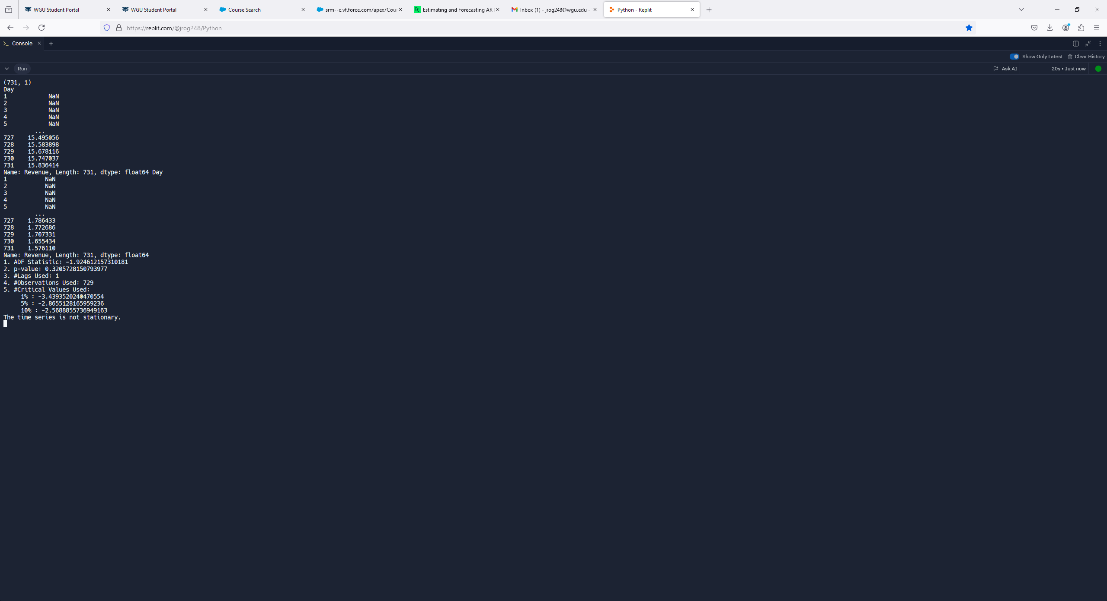

**(C6)**

The null hypothesis for this test is that the data is non-stationary. The ADF statistic is -1.92 which is greater than all the critical values and suggests that we cannot reject the null hypothesis. Furthermore, the p-value of 0.32 is considerably higher than the significance level of 0.05 which also indicates that the time series is non-stationary.

The conclusion of all these methods points towards the time series being non-stationary and will require differencing before any further analysis can be performed.

**C4. Preparation Analysis**

The data has already been reviewed for missing data and now requires differencing as determined by the various stationarity methods considered. The .diff() function was called in conjunction with .dropna() to difference the data. The visualizations of the annotated time series will be shown in the next section.

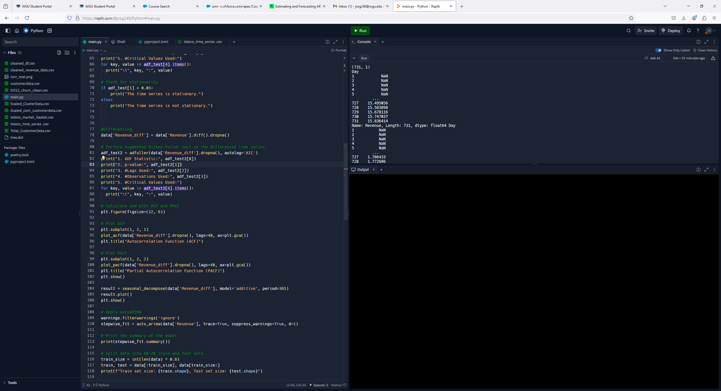

**(C7)**

Prior to building the model the data was split 80/20. The image below highlights the code segment as well as its associated output including the sizes of the training and test groups.

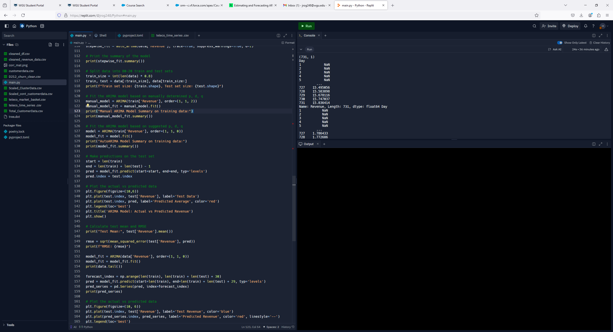

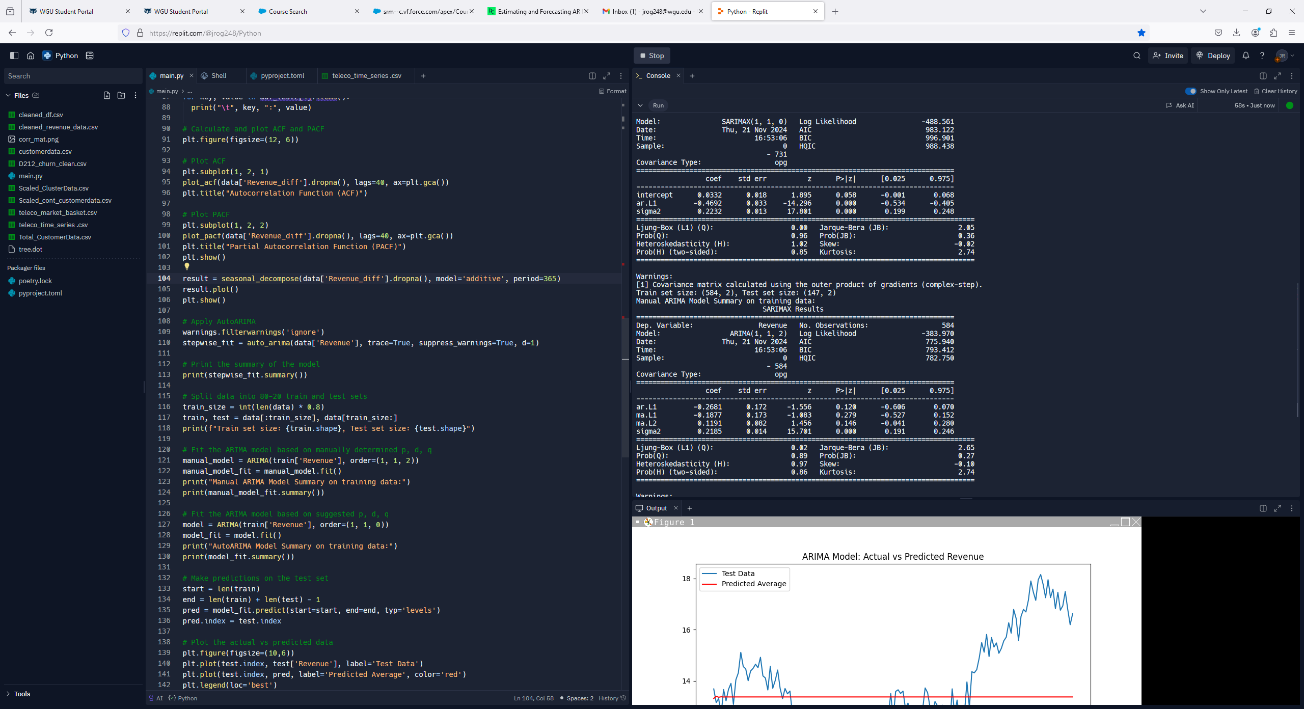

**(C8)**

**C5. Cleaned Data Set**

**Attached to submission:** cleaned_revenue_data.csv

**Part IV: Model Identification and Analysis**

**D1.  Annotated Findings**

After differencing the following visualizations were created for further analysis.

The ACF and PACF represented below confirm that the time series is now stationary. This can be verified by the fact that there is very little autocorrelation beyond the first lag. Upon review it looks like there is still some variation in the initial lags after differencing. In the manual ARIMA for this analysis the values p=1, d=2, and q=1 will be considered to see if they improve the model.

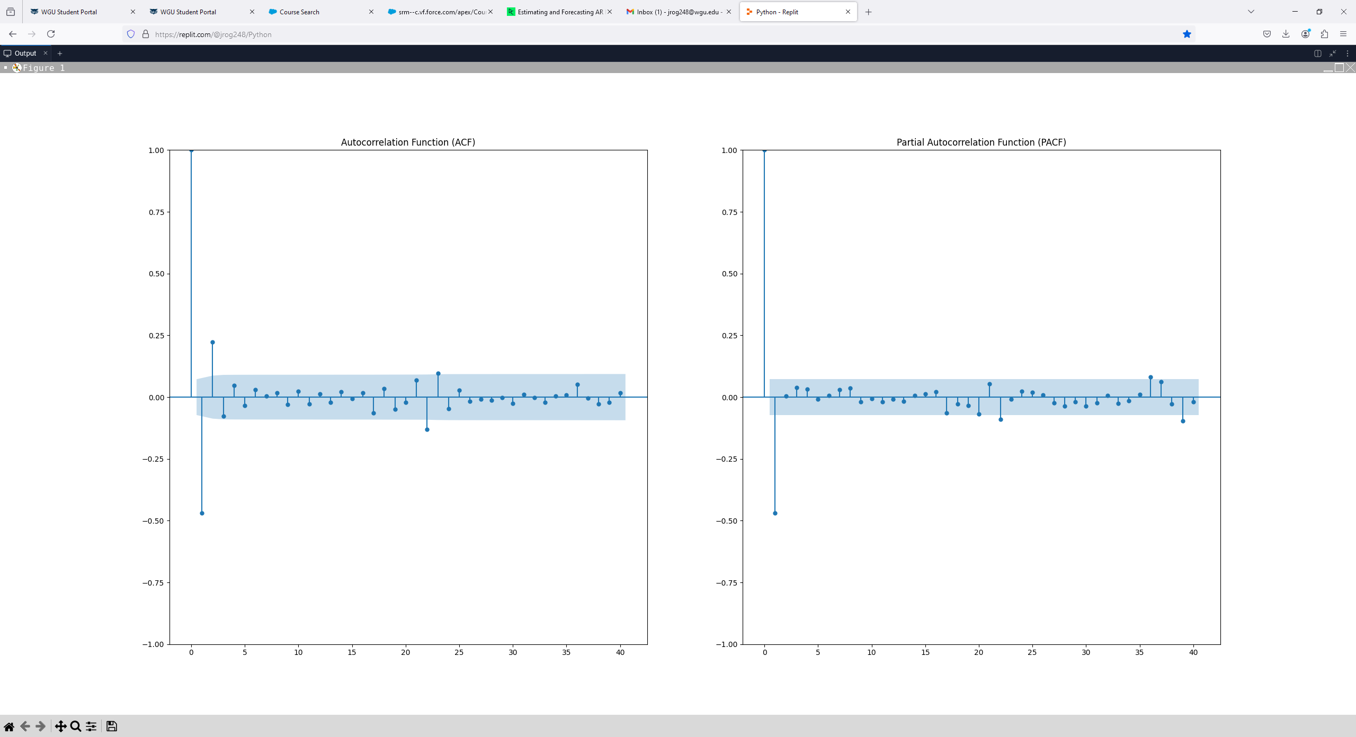

**(D1)**

Additionally, after differencing, the decomposed time series results also show stationarity. It is confirmed that there is no seasonality and there is now no real pattern displayed with the trend line.

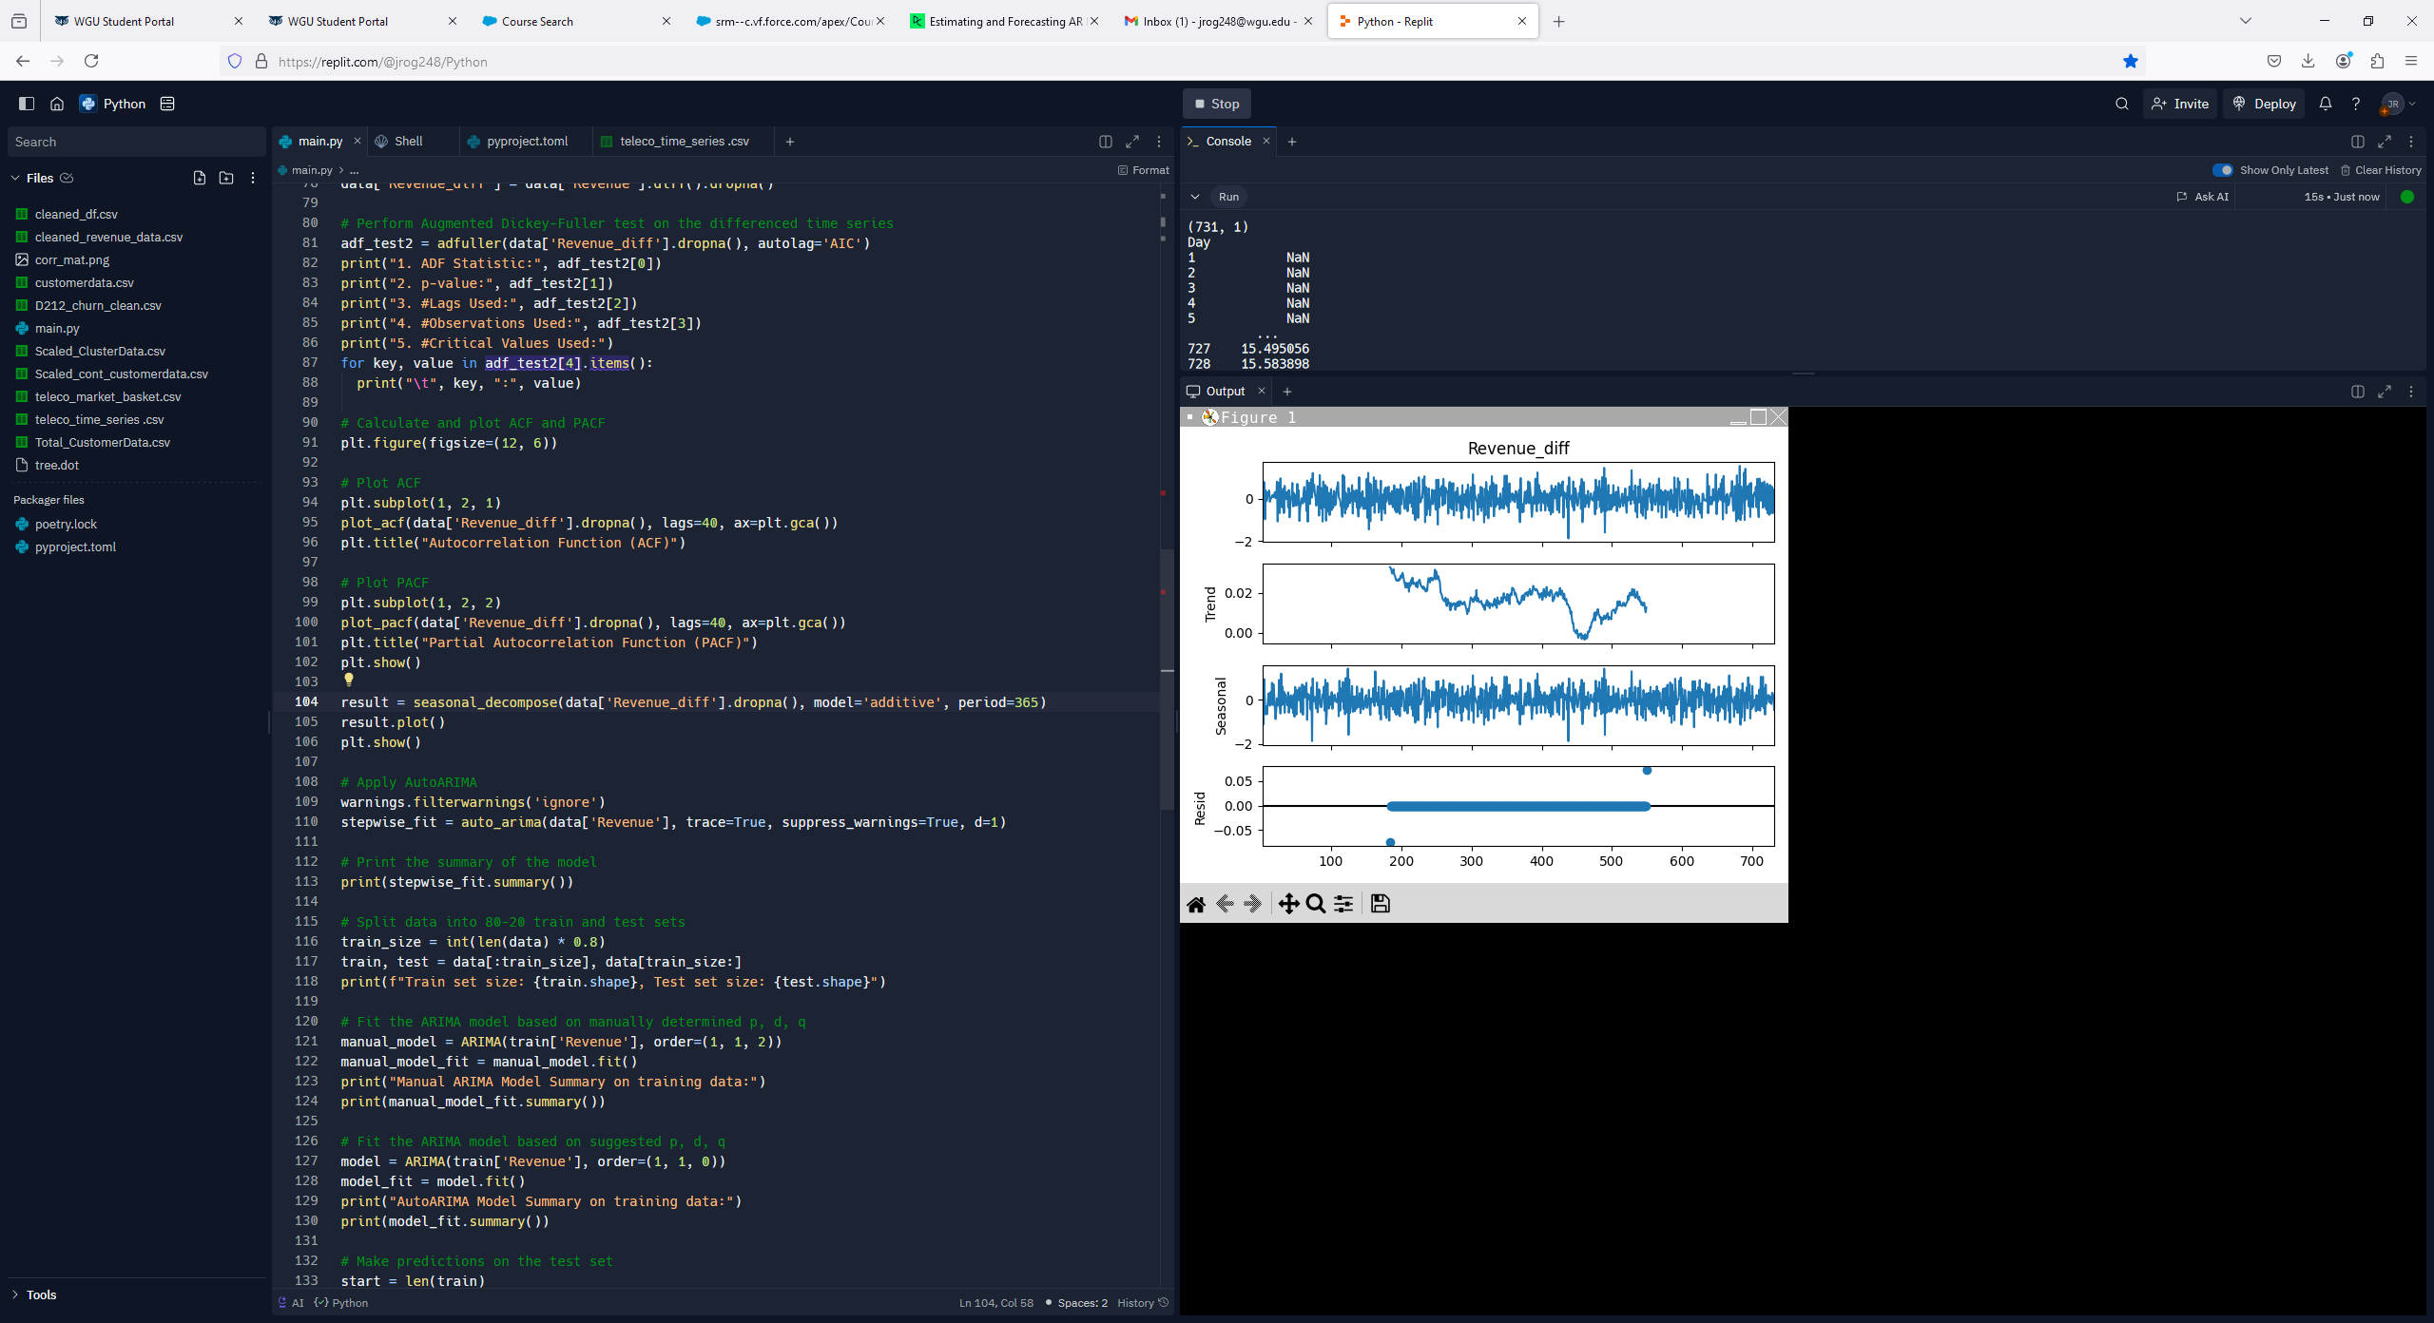

**(D2)**

Furthermore, an ADF test was performed on the annotated time series. The results show a p-value=0.0 and an ADF statistic of -44.87, which is much greater than the critical values. The differenced time series is now stationary and ready for ARIMA modeling.

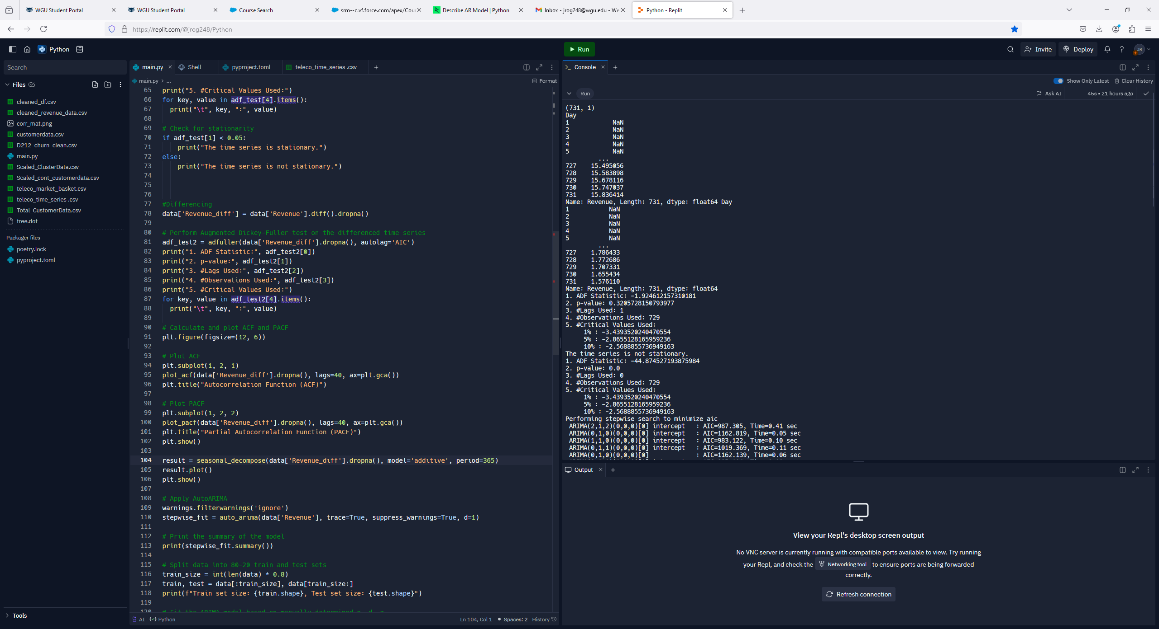

**(D3)**

**D2.  ARIMA Model**

Both an ARIMA and AutoARIMA were created during this analysis. First, an AutoARIMA was performed so that this function can automatically optimize the p, d, and q values. The code performed on the train data and resulting SARIMAX results are below.

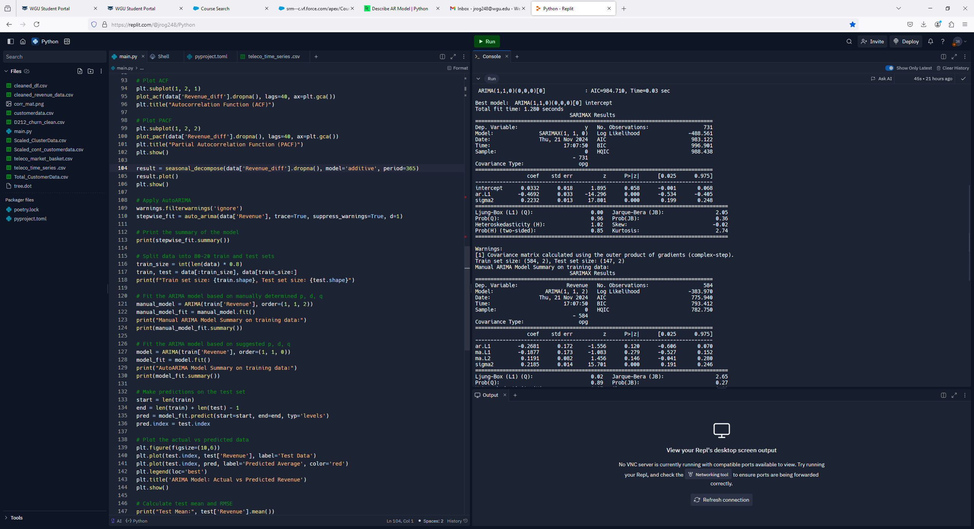

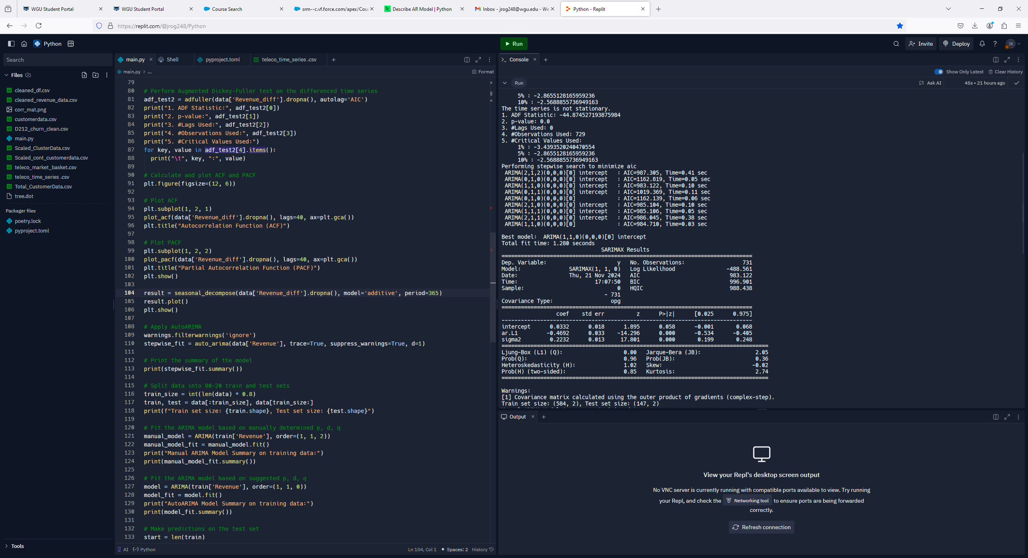

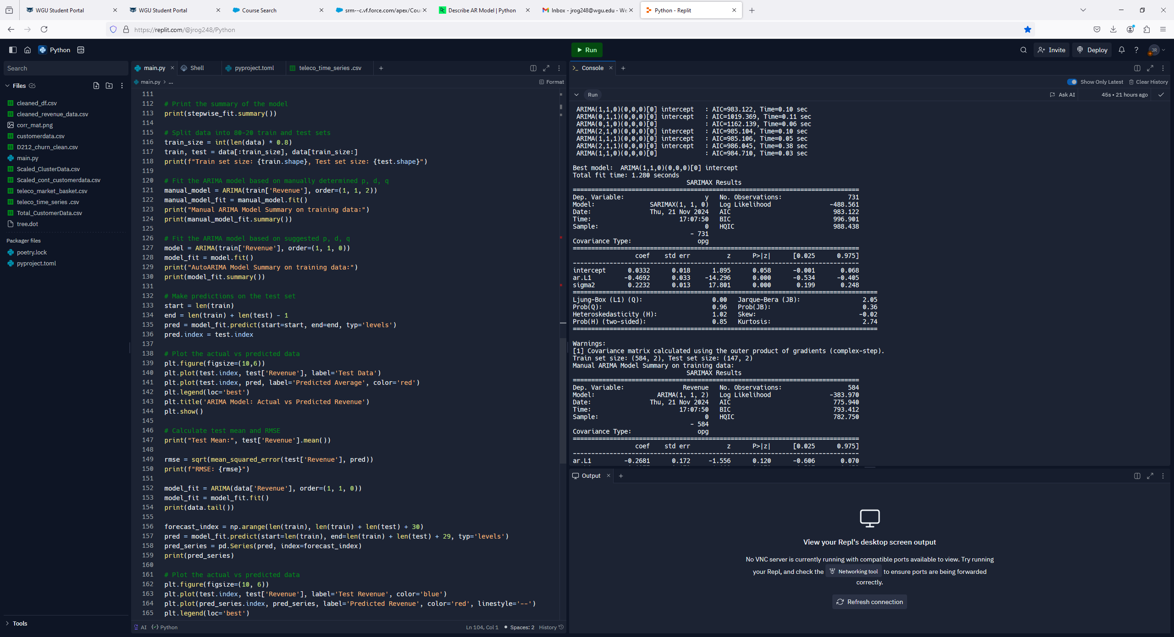

**(D4)**

The suggested values using AutoArima are p=1, d=1, and q=0. The zeroes following these values confirm that there is no seasonality with this time series. Furthermore, the SARIMAX results show relatively good p-values making with only one value slightly above the 0.05 significance level.

To improve the model an ARIMA with the values p=1, d=2, and q=1 was considered regarding the resulting single differencing and ACF and PACF visualizations. The code and output for this model is below.

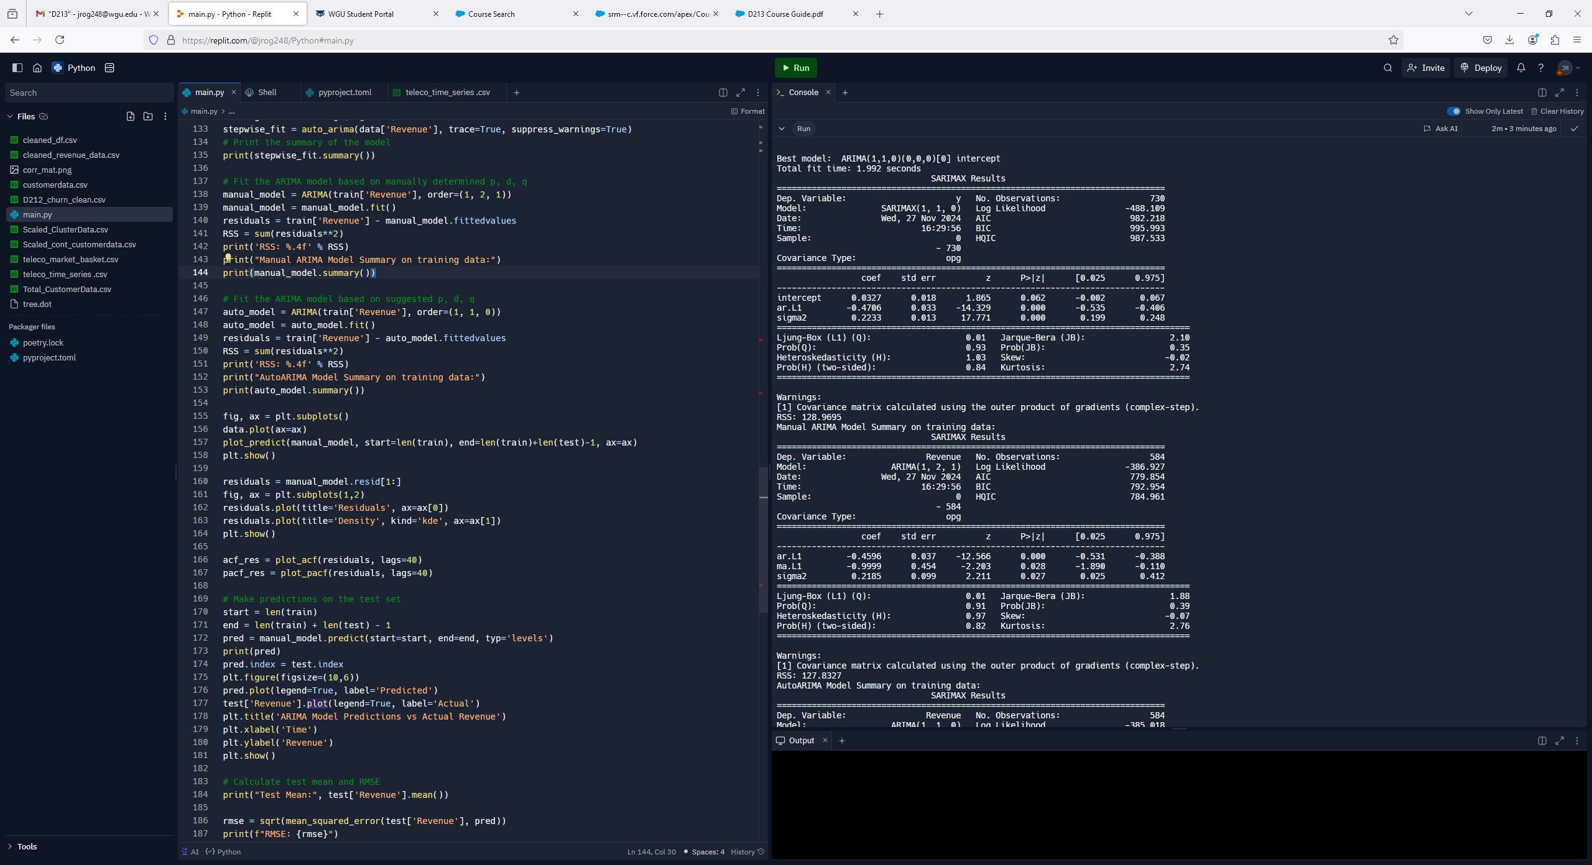



**(D5)**

The SARIMAX results show an AIC value of 779.85 and the p-values fall well within the 0.05 confidence level. This suggests that the p, d, and q values are a solid fit for this data. While the p-values and AIC value was lower with the AutoARIMA, it was decided to move forward with the values p=1, d=2, and q=1 as this additional differencing helps to accommodate the upward trend of the data.

**D3.  Forecast**

Below shows a visualization of the ARIMA model predictions on the test data. The prediction line trends upward and falls within the 95% confidence range.

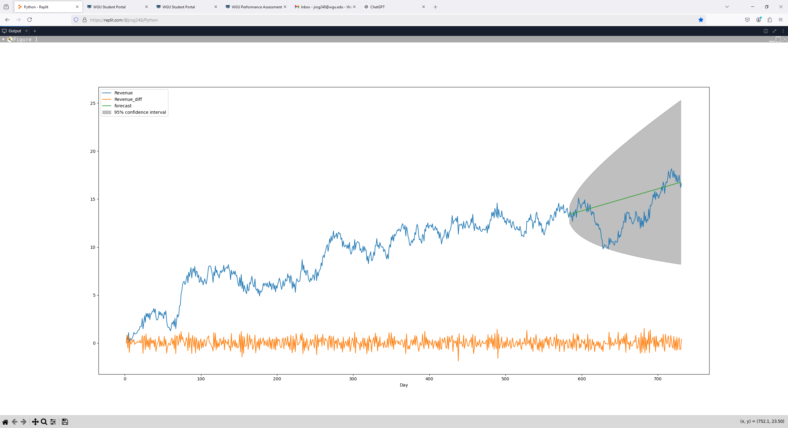

**(D6)**

With this level of confidence predictions were made on the next 30 days of revenue as determined by the ARIMA model. Below is an output of this data. It can be seen that an upward trend continues which aligns with the overall trend of the time series training data.

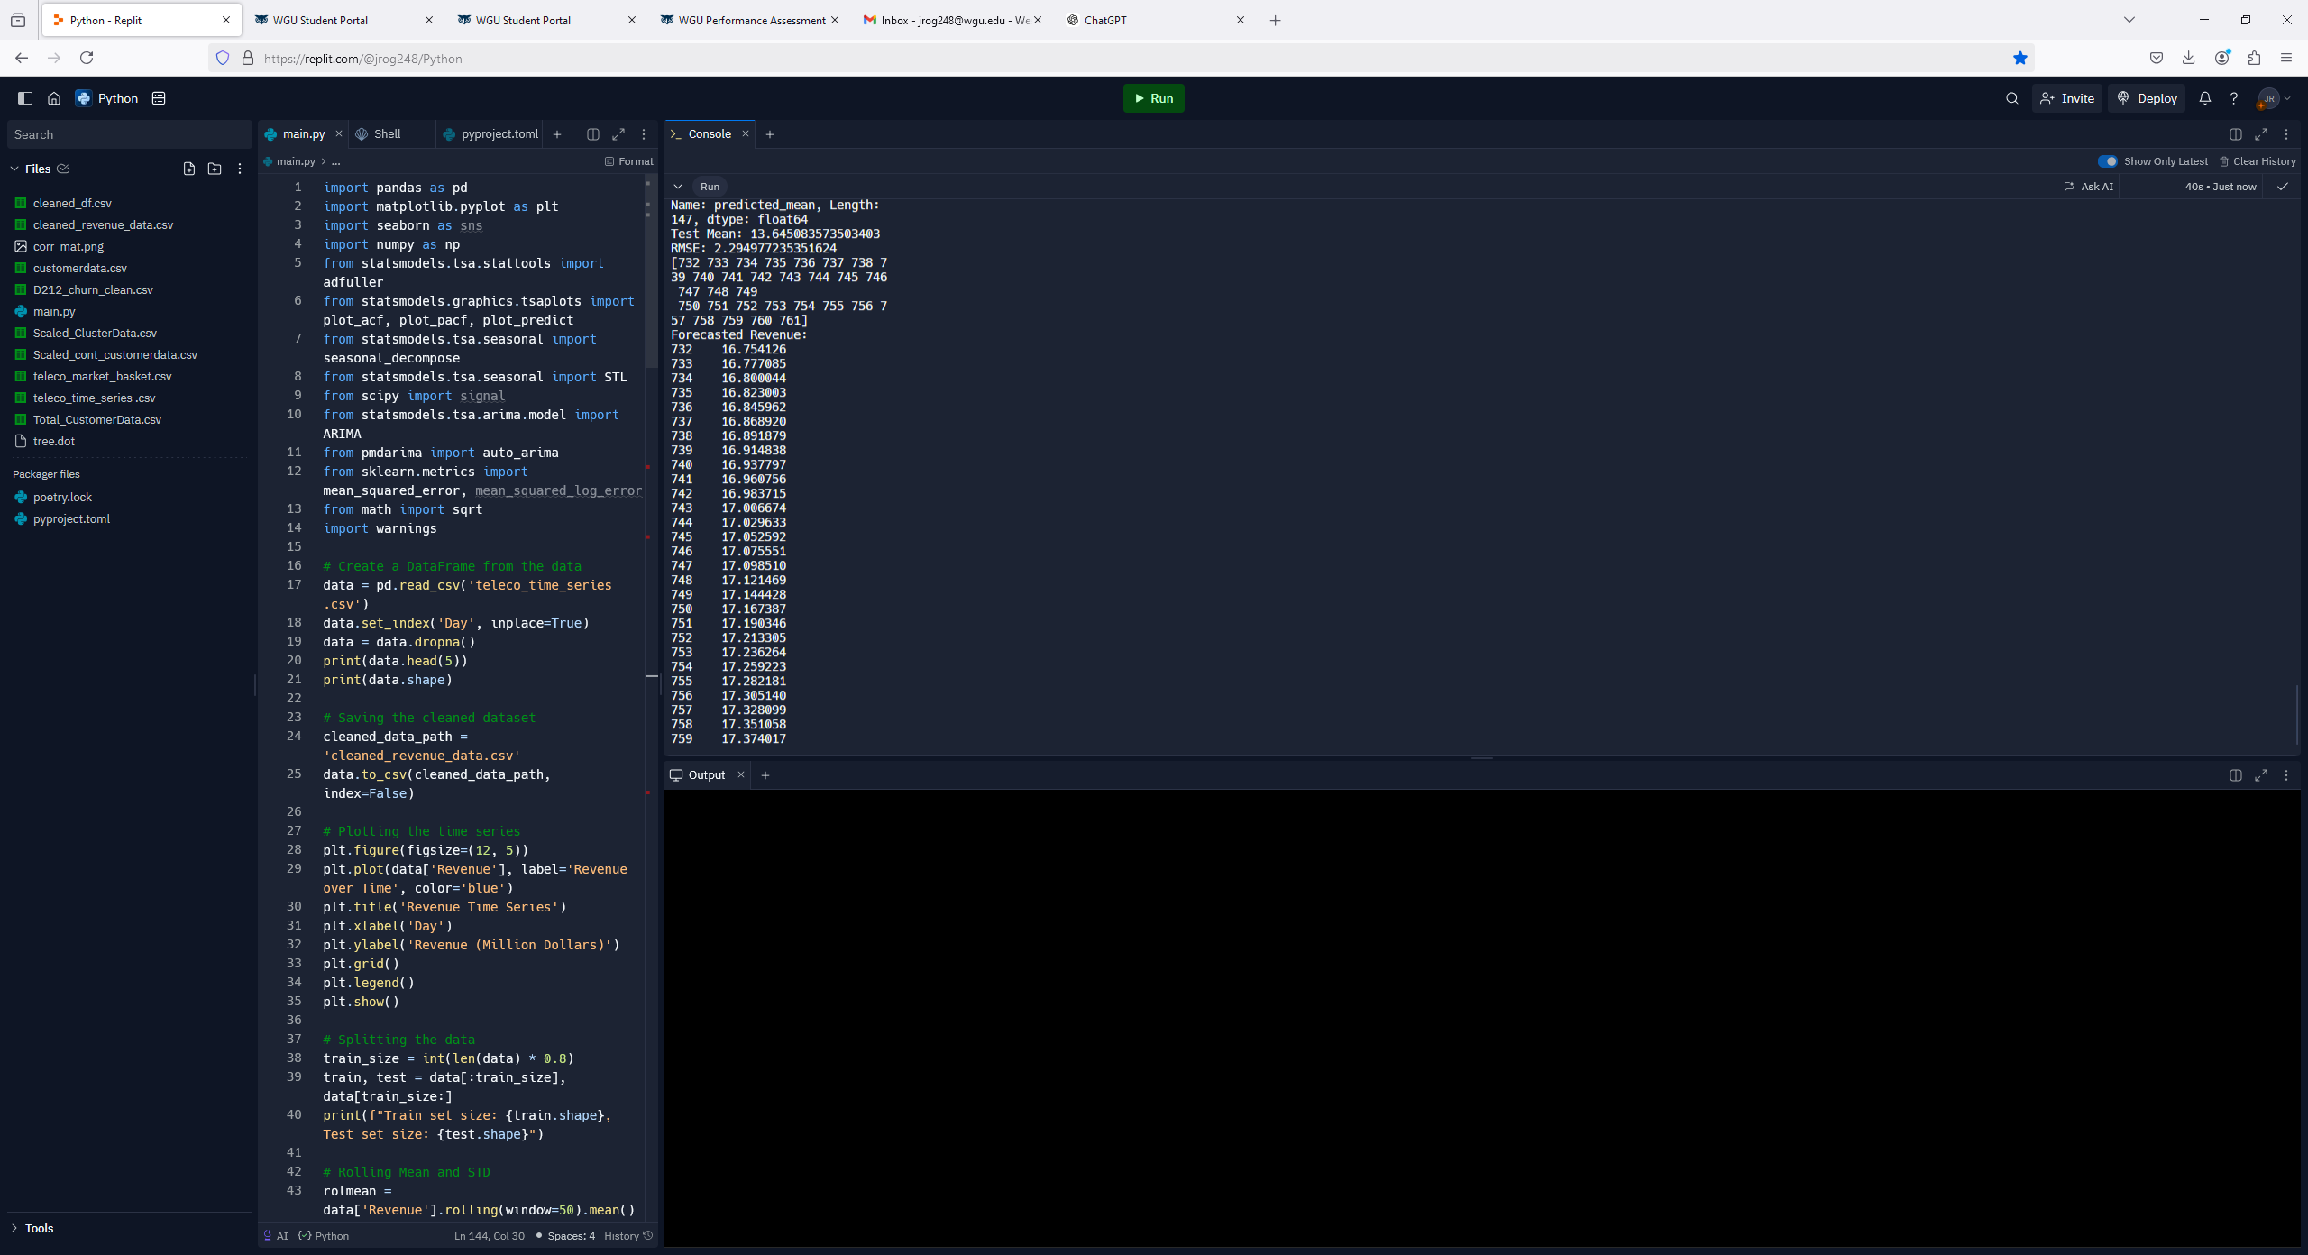

**(D7)**

Below is the code for forecasting revenue for the next 30 days.

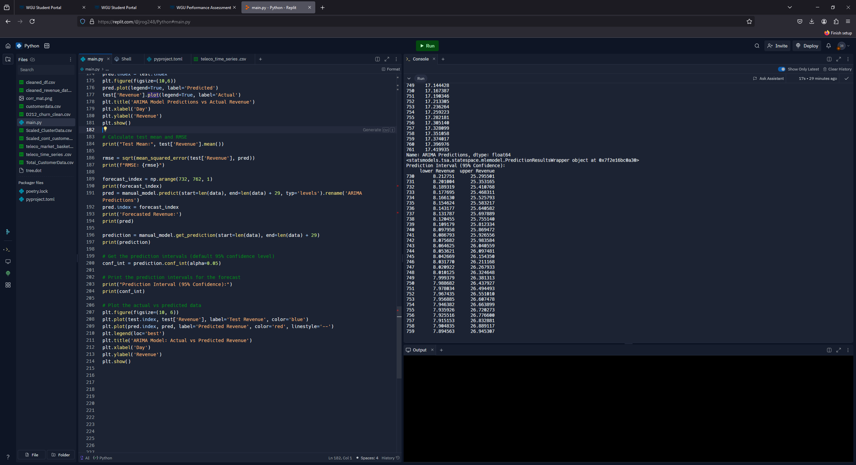

**(D8)**

**D4.  Output and Calculations**

First the test mean was calculated to compare to the forecasted results. As we can see below the test mean was 13.64 which is lower than the predicted values; however, the upward trend of the series suggests that this is reasonable. Additionally, the RMSE was calculated to evaluate the model’s accuracy. The resulting RMSE is 2.29 which is very low thus supporting the accuracy of the model.

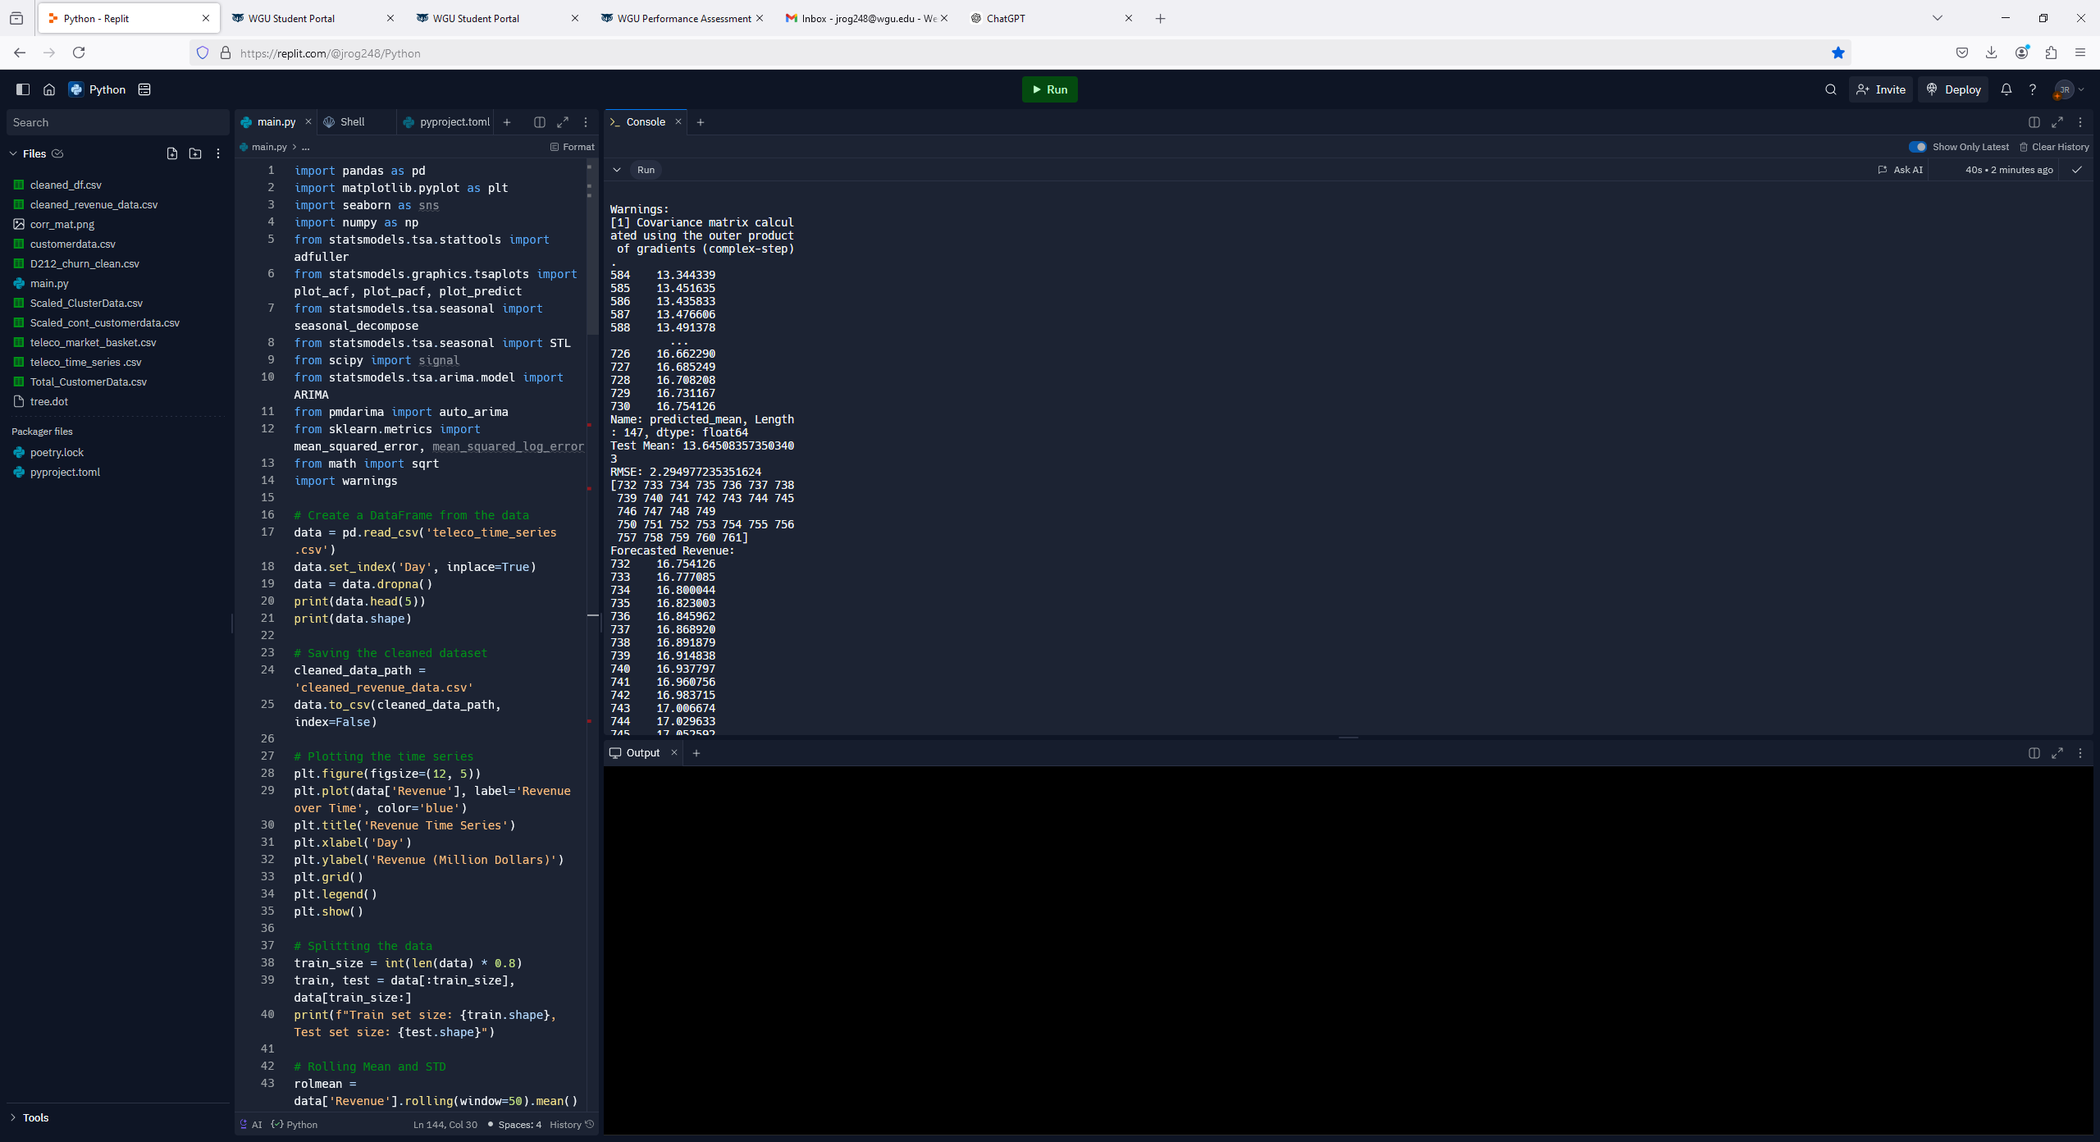

**(D9)**

Additional visualizations were created to verify the quality of the developed model. First, a graph of the residuals was created. Below you can see that the image of the residuals looks like white noise without any discernable patterns or trends.

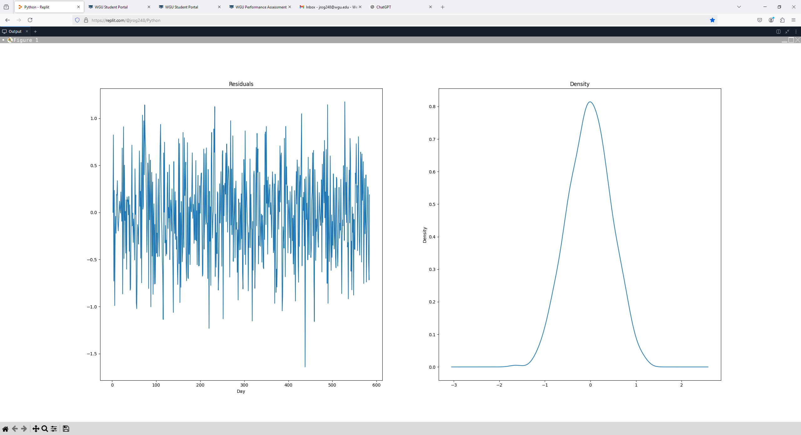

**(D10)**

Also, the creation of newly calculated ACF and PACF visualizations were utilized to demonstrate the lack of significant variation after the initial lag regarding the residuals.

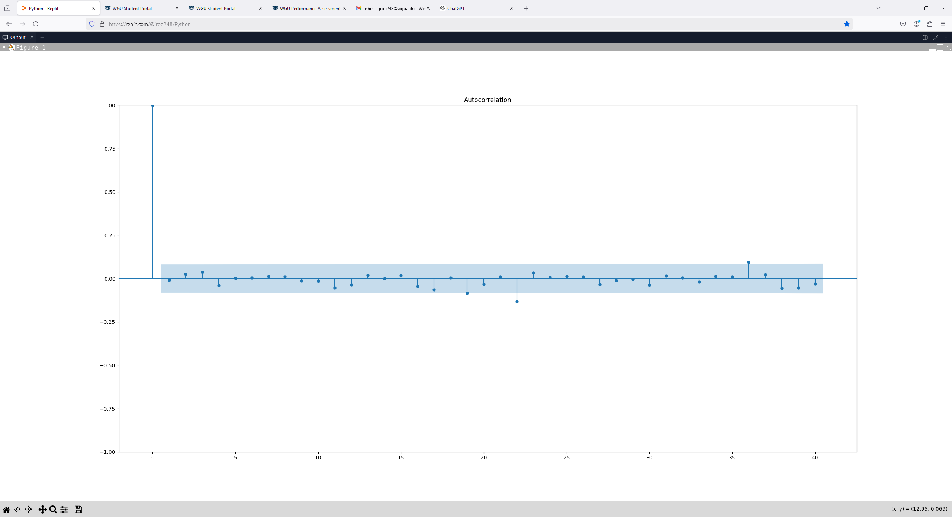

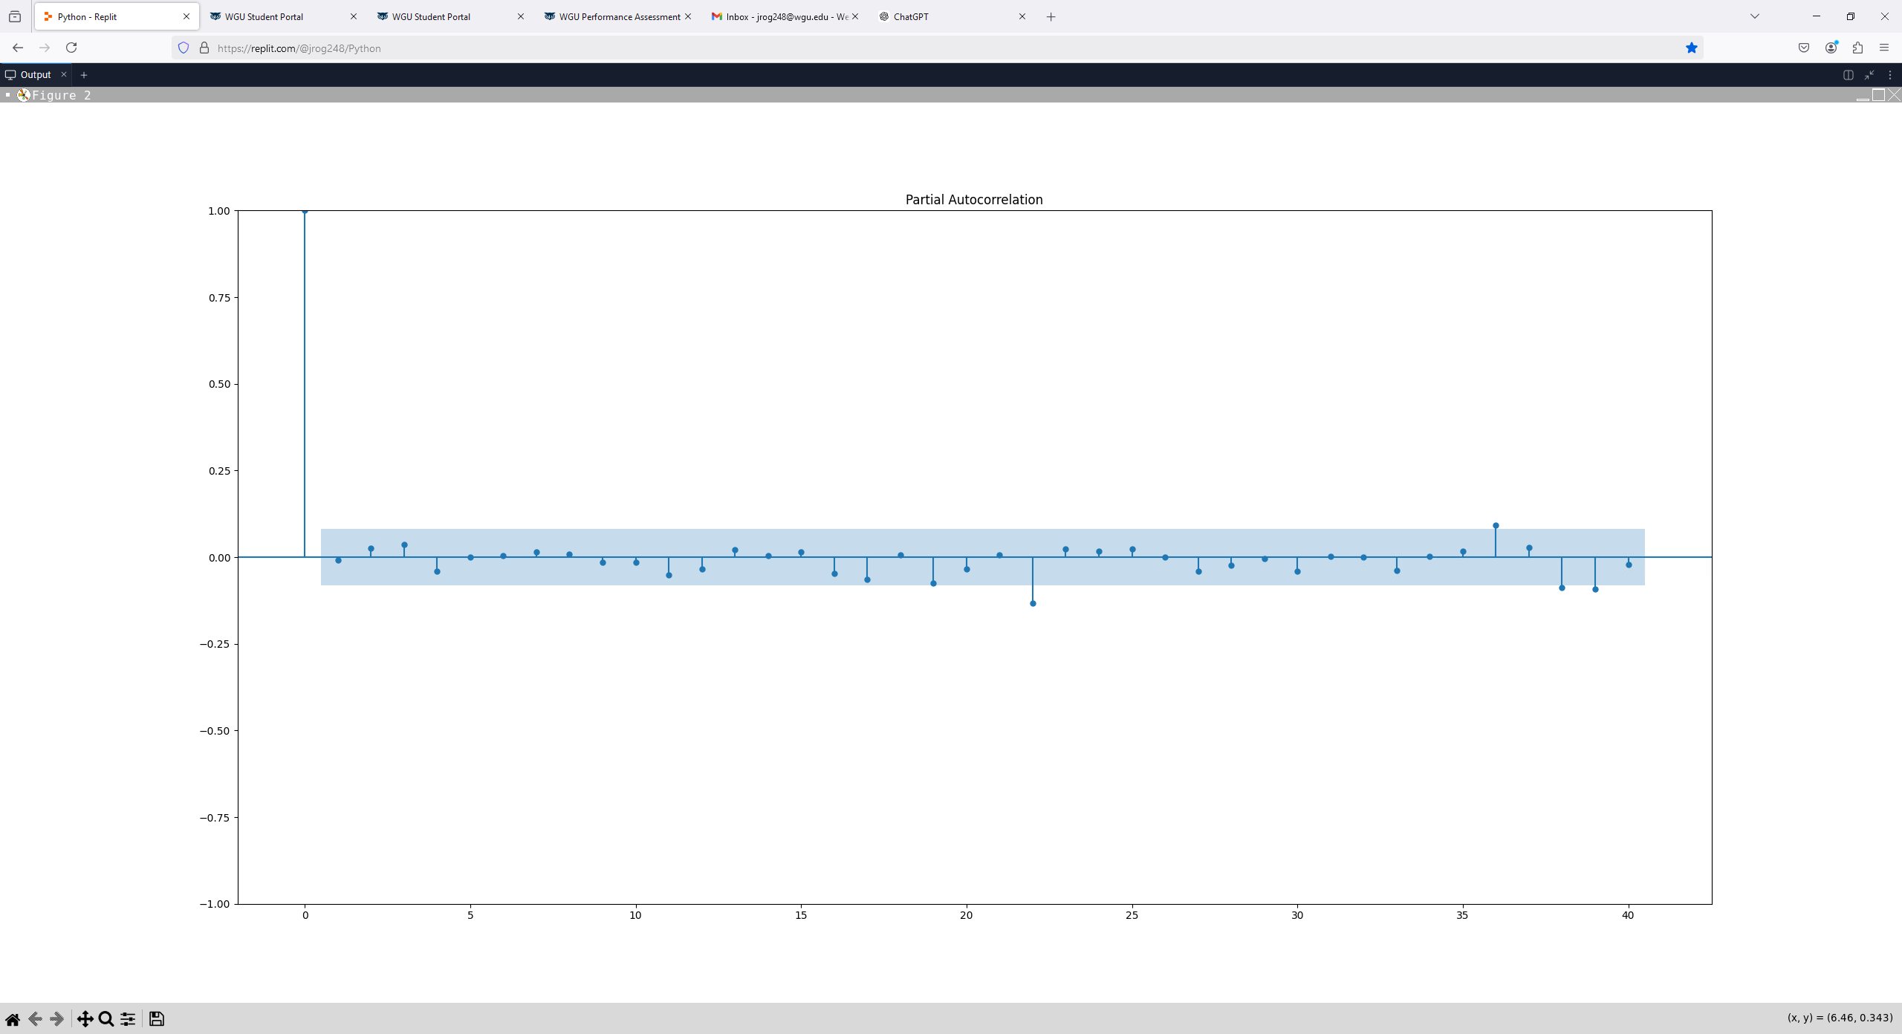

**(D11)**

**D5.  Times Series Model Code**

**Attached to submission:** D213_code_T1_Josh Rogers.py

**Part V: Data Summary and Implications**

**E1. Results Discussion**

Both AutoARIMA and manually created ARIMA models were considered for this analysis. While the AutoARIMA provided the p, d, q values of 1, 1, 0, respectively, the resulting ACF and PACF visualizations suggested that additional differencing may be required. Thus, the p, d, q values of 1, 2, 1, were selected for modeling. These values were vetted by reviewing the SARIMAX results and reviewing the p-values to ensure they fell into the appropriate 95% significance level.

The prediction intervals for the forecasted values can be found below. The wide range of these intervals suggests a relatively high level of uncertainty with the model. This is especially important to consider when determining potential bonuses to employees as these numbers represent millions of dollars. There may be higher risk involved based on the significant width of the forecasted intervals.

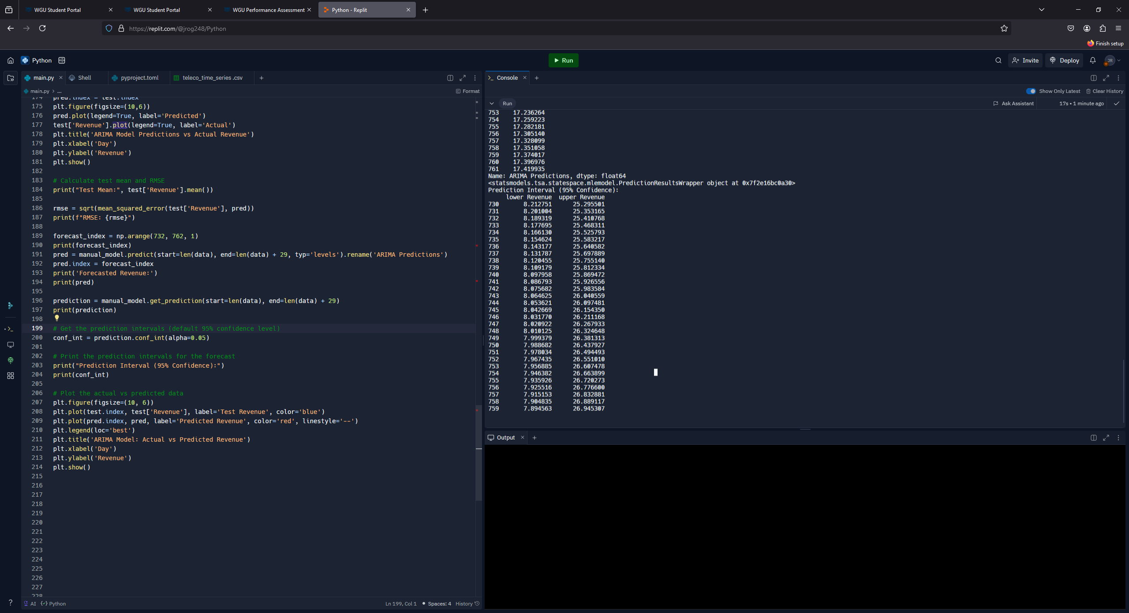

**(E1)**

The length of the forecast was determined using a couple of different factors. First, the shorter 30 day forecast length is usually going to yield more accurate model results. This is because the model will rely much more on recent day considerations. Secondly, the question being posed involves holiday bonuses which is more current and does not require major long-term projections.

The model was evaluated using both the RMSE and a visualization of the residual data. The RMSE value was determined to be 2.29. Given the large range of the revenue data this value appears validate the accuracy of the model. However, if we consider that this value’s units is millions of dollars, it may be too large of a number to put too much faith in the accuracy of the model.

**E2. Final Annotated Forecast Visualization**

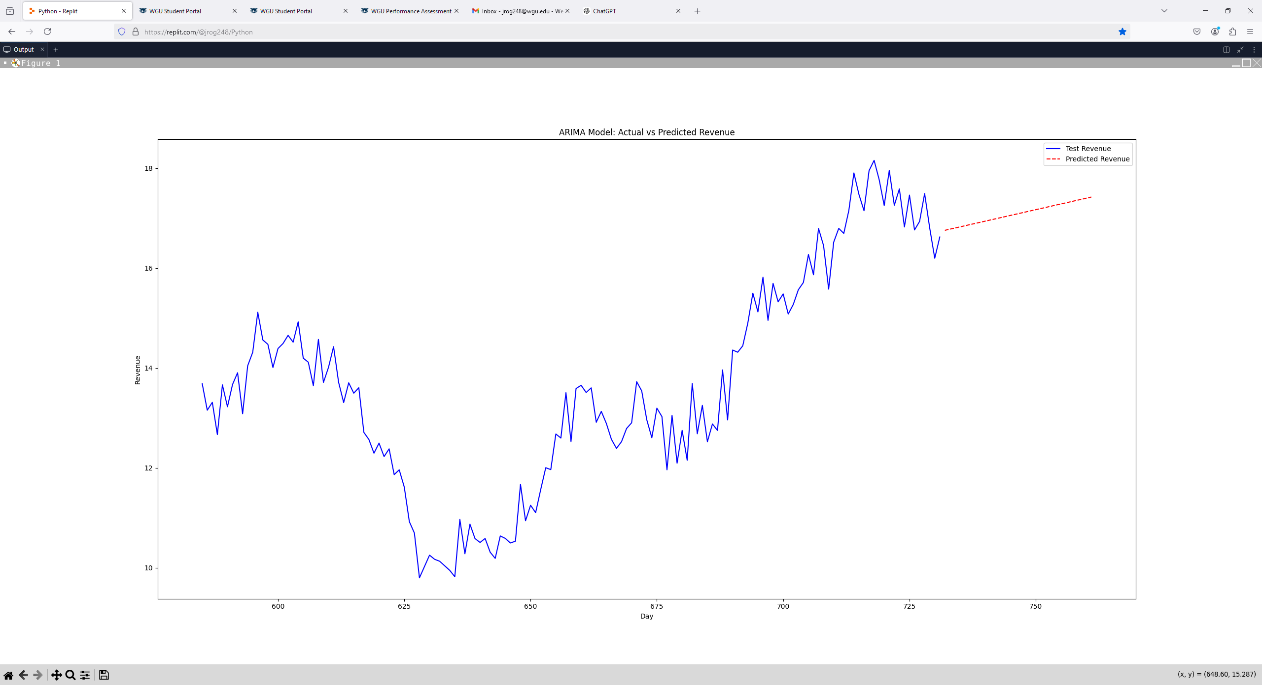

**(E2)**

**E3. Recommended Course of Action**

As we consider the original question of a predictive time series model and its ability to provide guidance for a company in relation to offering holiday bonuses, the resulting model is helpful. The original time series does show an overall upward trend in revenue which is encouraging, and the model developed further supports an upward trend over the next 30 days. However, the variability of the model demonstrates a lack of confidence of the predicted values. Even given this information, my recommendation for the organization is to still consider providing employee bonuses with the caveat to ensure that the amounts are reasonable and account for potential revenue fluctuation. Providing such a gift to the employees will improve morale and will hopefully reflect in organizational performance moving forward. Future considerations surrounding holiday bonuses and their impact on revenue can be evaluated once enough such data is collected.

**Part V: Reporting**

**Attached to submission:** Revenue_Forecast_Results.pdf

**Sources**

Pandian, S. (2023, November 9). *Time series analysis and forecasting | data-driven insights (Updated 2023)*. Analytics Vidhya. https://www.analyticsvidhya.com/blog/2021/10/a-comprehensive-guide-to-time-series-analysis/

*Topic 2: Time series & Autocorrelation*. (n.d.). https://online.stat.psu.edu/stat501/book/export/html/995

**Code Sources**

Jam75. (2023, December 14). *FPDF encoding problem*. Discussions on Python.org. https://discuss.python.org/t/fpdf-encoding-problem/41052